Geography Educators’ Network of Indiana/GENI Zoom Room
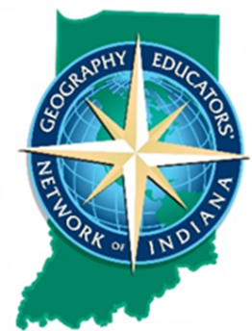
Indiana Council for the Social Studies
2020 Annual Conference Virtual
October 21/22/24

Hosted by: Troy Hammon, Shortridge High School, International Baccalaureate Programs &
Kathy Lamb Kozenski, GENI Executive Director

- WELCOME!

- Introduction to a few Teaching & Learning with GIS geo-resources
  - M&M Community Map activity
  - IndianaMap (https://maps.indiana.edu/)
  - IndianaView (https://www.indianaview.org/)
  - iNaturalist (https://www.inaturalist.org/)
  - GeoSpatial Tutorials on GPS, Remote Sensing, and GIS (https://geni.iupui.edu/?page_id=214)
      - Tutorial I: Land Use Change (high school)
      - Tutorial II: Water & Drought, Two Sides of the Same Coin (high school)
  - GIS for Middle School Students: Natural Hazards (https://geni.iupui.edu/?page_id=482)
      - Zombie Apocalypse (lesson plan and aerial imagery; assets and liabilities)
- ESRI ArcGIS educator account/student bundles (https://www.esri.com/en-us/industries/education/schools/schools-mapping-software-bundle)
- Geo-Inquiries in various disciplines and grade levels (https://www.esri.com/en-us/industries/education/schools/geoinquiries-collections)
- Story Maps
  - What is it? (https://storymaps-classic.arcgis.com/en/gallery/#s=0)
  - Start templates (https://storymaps-classic.arcgis.com/en/app-list/)
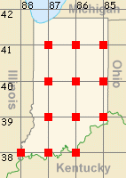
- Indianapolis metropolitan area geography data via SAVI (Social Assets & Vulnerabilities Indicators) (https://www.savi.org/)
- Josheph Kerski (https://www.josephkerski.com/)
- The Degree Confluence Project (http://confluence.org/)
- Books:
  - Me on the Map by Joan Sweeney (2-12)
  - How to Make an Apple Pie and See the World by Marjorie Priceman (K-6)
  - There’s a Map on My Lap by Tish Rabe (3-6)
  - The Tiny Seed by Eric Carle (2-6)
  - The Lorax by Dr. Seuss (4-12)
  - Warm as Wool by Scott Russell Sanders (3-6)
  - The Littlest Duckling by Gail Herman (PK)
  - Mapping Penny’s World by Loreen Leedy (4-7)
  - Lindsey the GIS Professional by Tyler Danielson (https://www.bolton-menk.com/books/lindsey/Lindsey.html) (4-12; on-line free book)
  - The Seagoing Cowboy by Peggy Reiff Miller (4-12; IN connection; Heifer Project)
  - The Water Wars by Cameron Stracher
  - Cod: A Biography of the Fish that Changed the World / The Cod’s Tale… by Mark Kurlansky
  - Salt: A World History / The Story of Salt by Mark Kurlansky

- Questions/Sharing/Ideas/Geo-Needs

- Upcoming P.D.
  - Creating Maps from Excel (webinar, 1 PGP)
  - Creating a Dashboard (webinar, 1 PGP)
  - Indiana and the Census (webinar, 1 PGP)

