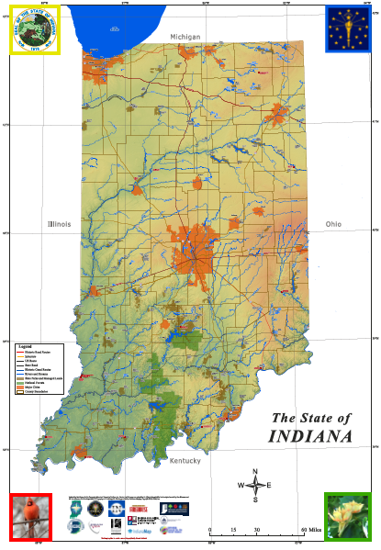
Giant Map of Indiana
Education Resource
GRANT

THANKS to an ATLAS Grant from the Indiana Geographic Information Office, GENI will deploy 20 Giant Maps of Indiana around the state to organizations/collaboratives demonstrating the ability and vision to teach and learn Geography and Geospatial Technologies. The Map will be a permanent resource for your organization to aid in the teaching and learning of 21st Geography and Geospatial Technologies! The GMIN measures 10’ east/west x 16’ north/south and is printed on light-weight vinyl, folds into a manageable size and contains LOTS of information about the state.
Applicants MUST be willing to:
- Participate in a Giant Map of Indiana Professional Development Training (required) and occasional virtual support as needed.
- Engage Educators, Students & the Community in the teaching & learning of Geography utilizing the Giant Map of Indiana (guidance and support provided)
- Employ the Giant Map of Indiana (at least) monthly in a teaching & learning environment
- Complete an Evaluation after each Giant Map of Indiana teaching & learning session
Schools, school corporations, libraries, museums, after-school programs, parks, 4-H, FFA, Scouts… rural, suburban, urban. All are welcome to apply! The goal is to USE THE MAP, not to have it sitting around gathering dust!!!
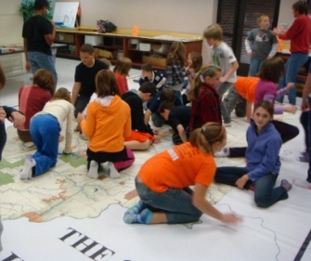
Apply: On-line at https://geni.indianapolis.iu.edu OR complete the questions below in a Word/PDF document and e-mail to geni@iu.edu or postal mail to the address below. DEADLINE: September 3, 2026
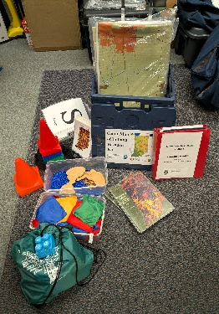
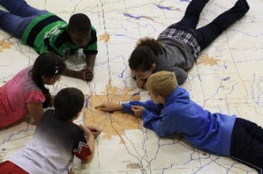
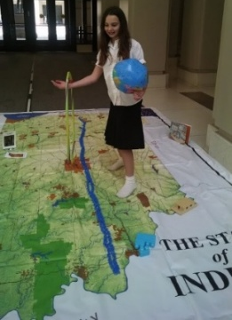
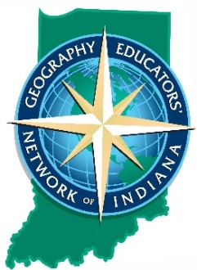

GENI/Geography CA 323A
425 University Blvd.
Indianapolis IN 46202-5140
geni@iu.edu
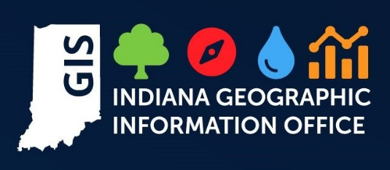
317.274.8879
Application for the Giant Map of Indiana GRANT

Name of Applicant(s):
Organization(s)/Collaborative:
Postal Address:
Telephone number:
E-mail:
Website:
The Giant Maps of Indiana have been in existence since the 1990’s and have undergone several updates by talented and creative cartographers: undergraduate students, GIS professionals, and professors, all with input and guidance from the PK-12 education community. GENI’s Giant Maps of Indiana have been utilized primarily in classrooms and schools, often shared by multiple schools in a corporation: grade-level specific activities, after-school enrichment in reading/writing/STEM/Geography Clubs, or students use the Map during Back-to-School/STEM/Parent Nights to reteach Geo-basics. Libraries have utilized the Maps for reading stories about places around the world, teaching about the Census and GeoCivics, understanding Indiana’s diverse PLACES, learning about the many cultures that make up Indiana’s human fabric, analyzing Indiana’s history and more. County Parks have utilized the Maps while educating about local ecology, biology, dune succession, wetlands distribution, Native Peoples, human and environment interaction, superfund sites, trash, water and more. Economic Development and Chamber of Commerce staff utilize the Maps to teach about local, state, national, and state economics and business to all ages, ensuring comprehension of Indiana’s connection to each other within the state and with the world. The intention is to maximize outreach in order to enrich Geographic Literacy!

VISION: Share your organization’s vision for the teaching and learning of Geography, Geographic Perspectives, Geospatial Technologies (whichever applies to your organization) utilizing the Giant Map of Indiana.

HOW & WHERE? Share a few ideas that you have about possible ways to utilize the Giant Map of Indiana (no right or wrong ideas!) across grade levels, disciplines, audiences, community events… Be creative!
- For example: at the school, across many schools in a corporation, libraries, museums, within a park education center, community centers, YMCA, county fairgrounds, economic development/chamber of commerce… Possibilities welcome!
- If your organization(s) plans to engage the community via outreach mechanisms, explain possible locations, partner organizations and outcomes.

Contact GENI with questions. It may take a while to return communication as we are not in the Office daily. THANK YOU for your interest in promoting a Geographically Literate Indiana…WHERE the SPATIAL jobs are!!! DEADLINE: September 3, 2026

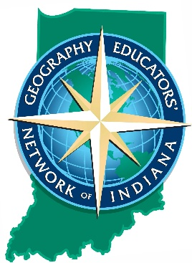

GENI/Geography CA 323A
425 University Blvd.
Indianapolis IN 46202-5140
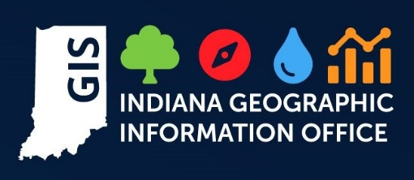
geni@iu.edu / 317.274.8879
https://geni.indianapolis.iu.edu

