GeoINquiries for a Better Future:
Teaching & Learning from a Spatial Perspective
Professional Development

THANKS to a ATLAS Grant from the Indiana Geographic Information Office…

Educators: (inservice/preservice, formal/informal, rural/suburban/urban)
- Schools
- Libraries and Museums
- Parks, 4-H, FFA, County Extension, Scouts and After-School Programs
- GIS/Geospatial Professionals

GOAL: To create 15 GeoINquiries for Indiana middle and high school (and general public) students and educators utilizing Indiana Geographic Information Sciences and Geospatial Resources connecting users to 21st century Geospatial perspectives about their world and beyond: for example using the IndianaMap, Landsat imagery, drone imagery, images from space, Giant Map of Indiana, Indiana Atlas, Census data, historic Sanborn Maps, LiDAR and more.

LOGISTICS:
- Participants gather in-person on September 11 to ensure a common foundation for creativity. Subsequent support provided virtually: brainstorming resources, applications, needs…guides for each other. Participants attend a Geographic Information Sciences event around the state (a local GIS Group, local data day, gather like-minded educators…).
- Stipends ($500.00) and travel ($500.00) will be provided for 15 participants.
- September 11 - begin in Indianapolis with a GeoTeam … goal to finish December 15. Monthly virtual gatherings as needed. Travel paid for September 11 gathering; stipend paid upon completion.
- Professional development certifications/recognitions available
- Deadline to apply is August 27 2026
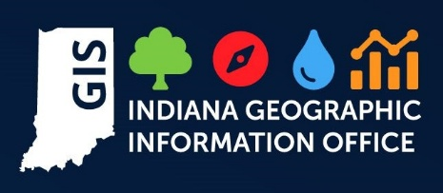
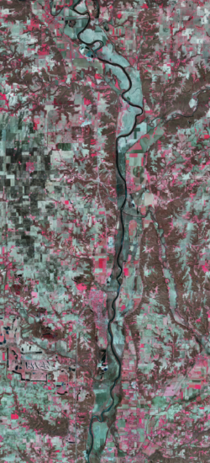
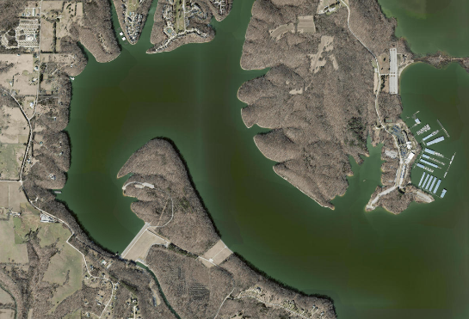
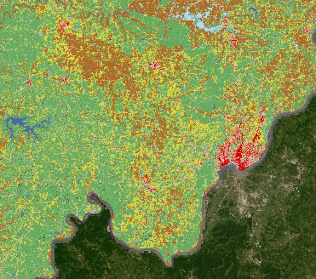
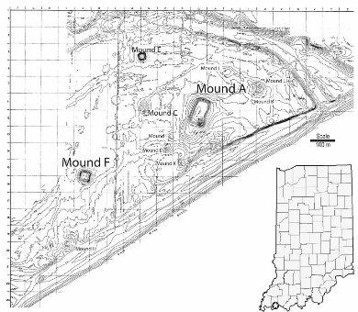
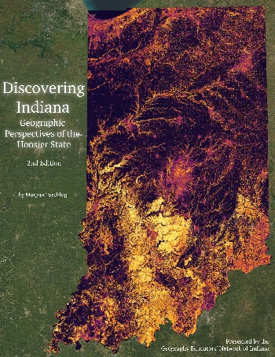
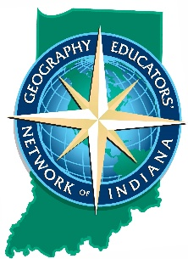
Application for the
GeoINquiries for a Better Future:
Teaching & Learning from a Spatial Perspective
Professional Development

Name of Applicant:
Organization/Affiliation:
Preferred Postal Address:
Preferred telephone number:
E-mail:

Profession:

If an Educator:
Grade level(s) you teach:

Subject area(s) you teach:

VISION: Share a vision for yourself and/or your (organizational) education outreach endeavors that you hope to improve your understanding of and your capacity to teach Geography and the Geospatial Technologies: whether in a classroom, at a library, at a nature center, at a fairgrounds or other locations encouraging better understanding of Indiana students sense of PLACE and their connections to places around the world and beyond to space.

Think of these questions when answering:
- WHY do you wish to participate?
- HOW will this opportunity improve your understanding of Geography and Geospatial
Technologies?
- HOW will this opportunity improve your capacity to teach Geography and Geospatial
Technologies?
- WHERE or WHO do you hope to reach [if not an educator] (or possibly beyond a traditional classroom if an educator)?

Contact GENI with questions. It may take a while to return communication as we are not in the Office daily. THANK YOU for your interest in promoting a Geographically Literate Indiana…WHERE the SPATIAL jobs are! We look forward to collaborating to create interesting, unique and IN relevant GeoINquiries.

DEADLINE: August 27, 2026 via e-mail

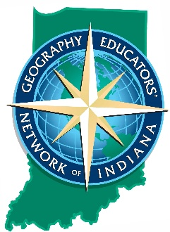
GENI/Geography CA 323A
425 University Blvd.
Indianapolis IN 46202-5140
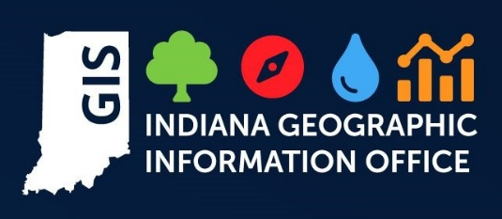
geni@iu.edu
317.274.8879

